**Crosstabs**

**pendidikan * kelompok**





**penghasilan * kelompok**





**paritas * kelompok**





**berat_badan * kelompok**





**laserasi_perineum * kelompok**





**perdarahan * kelompok**





**kat_Apgar1 * kelompok**





**kat_Apgar5 * kelompok**





**kat_nyeri1 * kelompok**





**kat_nyeri2 * kelompok**





**kat_nyeri3 * kelompok**





**Apgar1 * kelompok**



**Apgar5 * kelompok**



**Deskriptif statistik :**



**Uji normalitas data :**



**NPar Tests**

**Mann-Whitney Test**





**Crosstabs**

**VAS_pos1 * kelompok**





**VAS_Pos2 * kelompok**





**VAS_pos3 * kelompok**





**Deskriptif statistik VAS :**



**NPar Tests**

**Mann-Whitney Test**





**Persentase kenaikan VAS :**



**NPar Tests**

**Mann-Whitney Test**





FILTER OFF.

USE ALL.

EXECUTE.

EXAMINE VARIABLES=VAS_pos1 BY kelompok

/PLOT=BOXPLOT

/STATISTICS=NONE

/NOTOTAL.

**Explore**

|  |
| --- |
|  |

**kelompok**

|  |  |  |  |  |  |  |  |
| --- | --- | --- | --- | --- | --- | --- | --- |
| **Case Processing Summary** | | | | | | | |
|  | kelompok | Cases | | | | | |
| Valid | | Missing | | Total | |
| N | Percent | N | Percent | N | Percent |
| VAS_pos1 | Perlakuan | 30 | 100,0% | 0 | 0,0% | 30 | 100,0% |
| Kontrol | 30 | 100,0% | 0 | 0,0% | 30 | 100,0% |

**VAS_pos1**

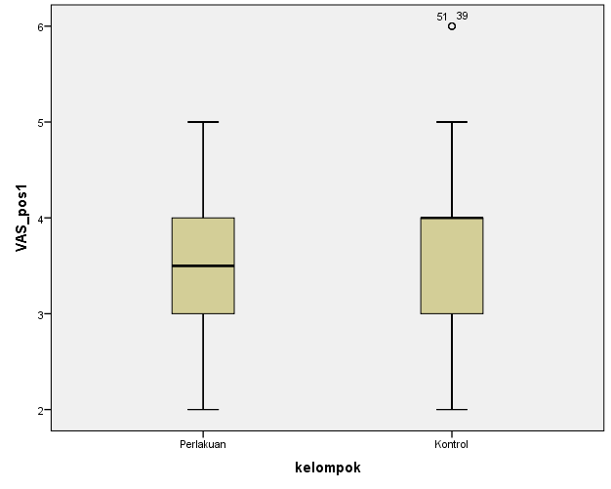

EXAMINE VARIABLES=VAS_Pos2 BY kelompok

/PLOT=BOXPLOT

/STATISTICS=NONE

/NOTOTAL.

**kelompok**

|  |  |  |  |  |  |  |  |
| --- | --- | --- | --- | --- | --- | --- | --- |
| **Case Processing Summary** | | | | | | | |
|  | kelompok | Cases | | | | | |
| Valid | | Missing | | Total | |
| N | Percent | N | Percent | N | Percent |
| VAS_Pos2 | Perlakuan | 30 | 100,0% | 0 | 0,0% | 30 | 100,0% |
| Kontrol | 30 | 100,0% | 0 | 0,0% | 30 | 100,0% |

**VAS_Pos2**

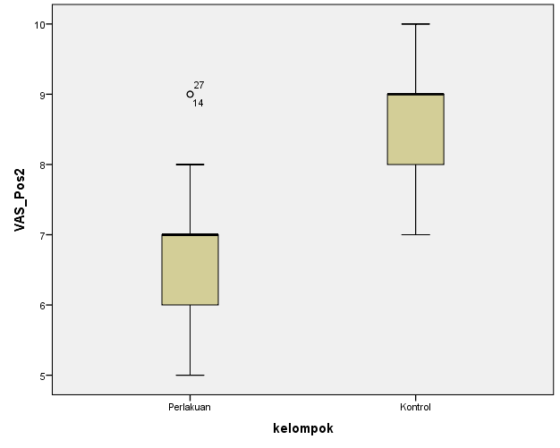

EXAMINE VARIABLES=VAS_pos3 BY kelompok

/PLOT=BOXPLOT

/STATISTICS=NONE

/NOTOTAL.

**kelompok**

|  |  |  |  |  |  |  |  |
| --- | --- | --- | --- | --- | --- | --- | --- |
| **Case Processing Summary** | | | | | | | |
|  | kelompok | Cases | | | | | |
| Valid | | Missing | | Total | |
| N | Percent | N | Percent | N | Percent |
| VAS_pos3 | Perlakuan | 30 | 100,0% | 0 | 0,0% | 30 | 100,0% |
| Kontrol | 30 | 100,0% | 0 | 0,0% | 30 | 100,0% |

**VAS_pos3**

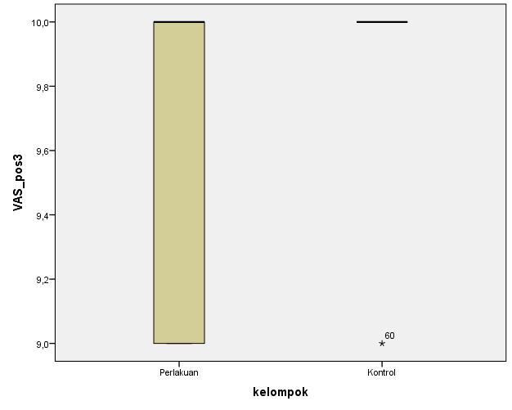

**Frequencies**

|  |  |  |  |  |  |
| --- | --- | --- | --- | --- | --- |
| **Statistics** | | | | | |
|  | | VAS_pos1 | VAS_Pos2 | VAS_pos3 | kelompok |
| N | Valid | 60 | 60 | 60 | 60 |
| Missing | 0 | 0 | 0 | 0 |
| Median | | 4,00 | 8,00 | 10,00 | 1,50 |
| Range | | 4 | 5 | 1 | 1 |
| Minimum | | 2 | 5 | 9 | 1 |
| Maximum | | 6 | 10 | 10 | 2 |
| Percentiles | 25 | 3,00 | 7,00 | 10,00 | 1,00 |
| 50 | 4,00 | 8,00 | 10,00 | 1,50 |
| 75 | 4,00 | 9,00 | 10,00 | 2,00 |

**Frequency Table**

|  |  |  |  |  |  |
| --- | --- | --- | --- | --- | --- |
| **VAS_pos1** | | | | | |
|  | | Frequency | Percent | Valid Percent | Cumulative Percent |
| Valid | 2 | 12 | 20,0 | 20,0 | 20,0 |
| 3 | 17 | 28,3 | 28,3 | 48,3 |
| 4 | 23 | 38,3 | 38,3 | 86,7 |
| 5 | 5 | 8,3 | 8,3 | 95,0 |
| 6 | 3 | 5,0 | 5,0 | 100,0 |
| Total | 60 | 100,0 | 100,0 |  |

|  |  |  |  |  |  |
| --- | --- | --- | --- | --- | --- |
| **VAS_Pos2** | | | | | |
|  | | Frequency | Percent | Valid Percent | Cumulative Percent |
| Valid | 5 | 1 | 1,7 | 1,7 | 1,7 |
| 6 | 12 | 20,0 | 20,0 | 21,7 |
| 7 | 11 | 18,3 | 18,3 | 40,0 |
| 8 | 12 | 20,0 | 20,0 | 60,0 |
| 9 | 23 | 38,3 | 38,3 | 98,3 |
| 10 | 1 | 1,7 | 1,7 | 100,0 |
| Total | 60 | 100,0 | 100,0 |  |

|  |  |  |  |  |  |
| --- | --- | --- | --- | --- | --- |
| **VAS_pos3** | | | | | |
|  | | Frequency | Percent | Valid Percent | Cumulative Percent |
| Valid | 9 | 11 | 18,3 | 18,3 | 18,3 |
| 10 | 49 | 81,7 | 81,7 | 100,0 |
| Total | 60 | 100,0 | 100,0 |  |

|  |  |  |  |  |  |
| --- | --- | --- | --- | --- | --- |
| **kelompok** | | | | | |
|  | | Frequency | Percent | Valid Percent | Cumulative Percent |
| Valid | Perlakuan | 30 | 50,0 | 50,0 | 50,0 |
| Kontrol | 30 | 50,0 | 50,0 | 100,0 |
| Total | 60 | 100,0 | 100,0 |  |