**Crosstabs**

**gravida * Kelompok**





**kat_pekerjaan * Kelompok**





**kat_pemb_serviks_datang * Kelompok**

|  |  |  |  |  |  |
| --- | --- | --- | --- | --- | --- |
| **Crosstabulation** | | | | | |
|  | | | Kelompok | | Total |
| Diberi minuman | Tdk diberi minuman |
| pembukaan_serviks | pembukaan2 | Count | 11 | 9 | 20 |
| % within Kelompok | 36,7% | 30,0% | 33,3% |
| pembukaan3 | Count | 19 | 21 | 40 |
| % within Kelompok | 63,3% | 70,0% | 66,7% |
| Total | | Count | 30 | 30 | 60 |
| % within Kelompok | 100,0% | 100,0% | 100,0% |

|  |  |  |  |  |  |
| --- | --- | --- | --- | --- | --- |
| **Chi-Square Tests** | | | | | |
|  | Value | df | Asymp. Sig. (2-sided) | Exact Sig. (2-sided) | Exact Sig. (1-sided) |
| Pearson Chi-Square | ,300a | 1 | ,584 |  |  |
| Continuity Correctionb | ,075 | 1 | ,784 |  |  |
| Likelihood Ratio | ,300 | 1 | ,584 |  |  |
| Fisher's Exact Test |  |  |  | ,785 | ,392 |
| Linear-by-Linear Association | ,295 | 1 | ,587 |  |  |
| N of Valid Cases | 60 |  |  |  |  |
| a. 0 cells (,0%) have expected count less than 5. The minimum expected count is 10,00. | | | | | |
| b. Computed only for a 2x2 table | | | | | |

**kat_kecemasan * Kelompok**





**kat_intensitas_kontr_uterus_laten * Kelompok**

|  |  |  |  |  |  |
| --- | --- | --- | --- | --- | --- |
| **Crosstab** | | | | | |
|  | | | Kelompok | | Total |
| Diberi minuman | Tdk diberi minuman |
| kat_intensitas_kontr_uterus_laten | lemah | Count | 27 | 30 | 57 |
| % within Kelompok | 90,0% | 100,0% | 95,0% |
| kuat | Count | 3 | 0 | 3 |
| % within Kelompok | 10,0% | 0,0% | 5,0% |
| Total | | Count | 30 | 30 | 60 |
| % within Kelompok | 100,0% | 100,0% | 100,0% |

|  |  |  |  |  |  |
| --- | --- | --- | --- | --- | --- |
| **Chi-Square Tests** | | | | | |
|  | Value | df | Asymp. Sig. (2-sided) | Exact Sig. (2-sided) | Exact Sig. (1-sided) |
| Pearson Chi-Square | 3,158a | 1 | ,076 |  |  |
| Continuity Correctionb | 1,404 | 1 | ,236 |  |  |
| Likelihood Ratio | 4,317 | 1 | ,038 |  |  |
| Fisher's Exact Test |  |  |  | ,237 | ,119 |
| Linear-by-Linear Association | 3,105 | 1 | ,078 |  |  |
| N of Valid Cases | 60 |  |  |  |  |
| a. 2 cells (50,0%) have expected count less than 5. The minimum expected count is 1,50. | | | | | |
| b. Computed only for a 2x2 table | | | | | |

**kat_intensitas_kontr_uterus_aktif * Kelompok**

|  |  |  |  |  |  |
| --- | --- | --- | --- | --- | --- |
| **Crosstab** | | | | | |
|  | | | Kelompok | | Total |
| Diberi minuman | Tdk diberi minuman |
| kat_intensitas_kontr_uterus_aktif | lemah | Count | 7 | 18 | 25 |
| % within Kelompok | 23,3% | 60,0% | 41,7% |
| kuat | Count | 23 | 12 | 35 |
| % within Kelompok | 76,7% | 40,0% | 58,3% |
| Total | | Count | 30 | 30 | 60 |
| % within Kelompok | 100,0% | 100,0% | 100,0% |

|  |  |  |  |  |  |
| --- | --- | --- | --- | --- | --- |
| **Chi-Square Tests** | | | | | |
|  | Value | df | Asymp. Sig. (2-sided) | Exact Sig. (2-sided) | Exact Sig. (1-sided) |
| Pearson Chi-Square | 8,297a | 1 | ,004 |  |  |
| Continuity Correctionb | 6,857 | 1 | ,009 |  |  |
| Likelihood Ratio | 8,526 | 1 | ,004 |  |  |
| Fisher's Exact Test |  |  |  | ,008 | ,004 |
| Linear-by-Linear Association | 8,159 | 1 | ,004 |  |  |
| N of Valid Cases | 60 |  |  |  |  |
| a. 0 cells (0,0%) have expected count less than 5. The minimum expected count is 12,50. | | | | | |
| b. Computed only for a 2x2 table | | | | | |

**Deskriptif statistik :**

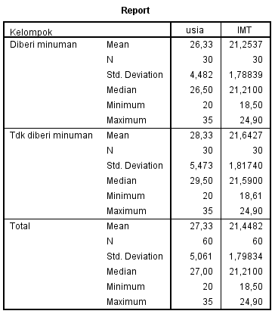

**Uji normalitas data :**

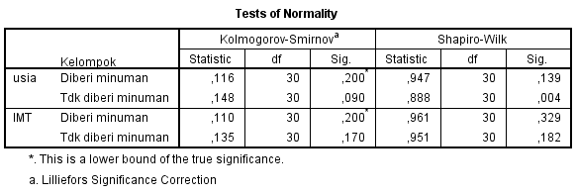

**Crosstabs**





**NPar Tests**

**Mann-Whitney Test**

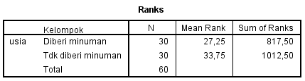

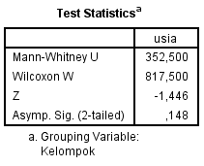

**T-Test**

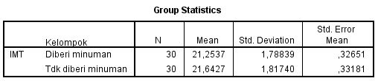

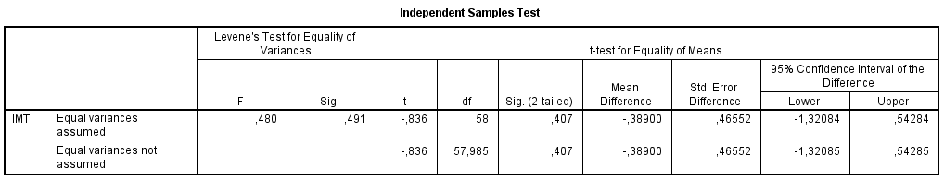

**Means**

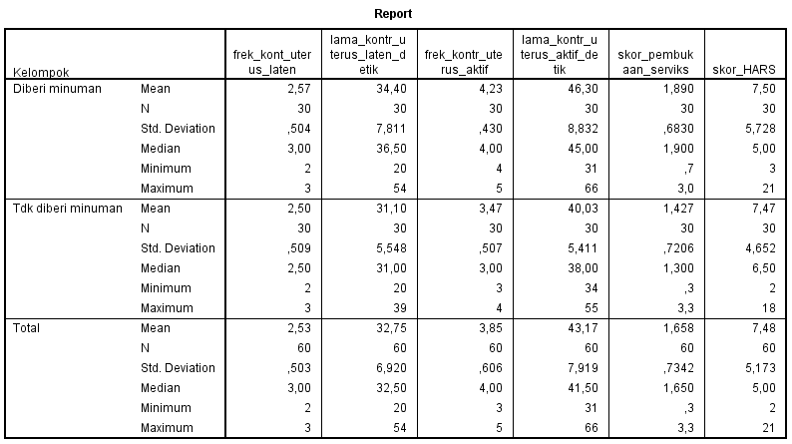

**Uji normalitas data :**

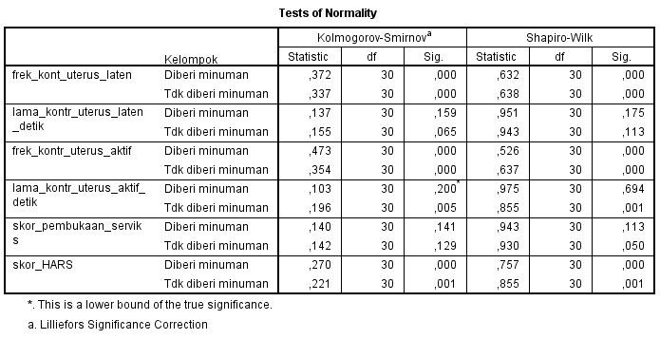

**T-Test**





**NPar Tests**

**Mann-Whitney Test**

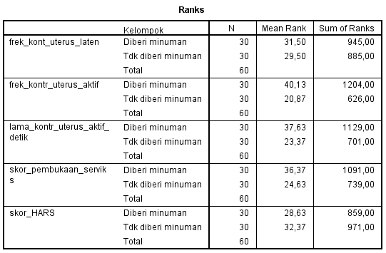

|  |  |  |  |  |  |
| --- | --- | --- | --- | --- | --- |
| **Test Statisticsa** | | | | | |
|  | frek_kont_uterus_laten | frek_kontr_uterus_aktif | lama_kontr_uterus_aktif_detik | skor_pembukaan_serviks | skor_HARS |
| Mann-Whitney U | 420,000 | 161,000 | 236,000 | 274,000 | 394,000 |
| Wilcoxon W | 885,000 | 626,000 | 701,000 | 739,000 | 859,000 |
| Z | -,513 | -4,950 | -3,171 | -2,611 | -,833 |
| Asymp. Sig. (2-tailed) | ,608 | ,000 | ,002 | ,009 | ,405 |
| a. Grouping Variable: Kelompok | | | | | |

**Crosstabs**





**Crosstabs**

**kelompok1 * kat_frek_uterus_aktif**

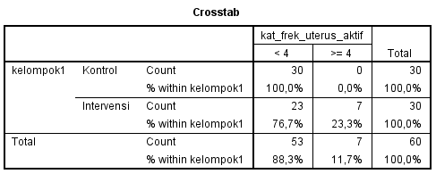

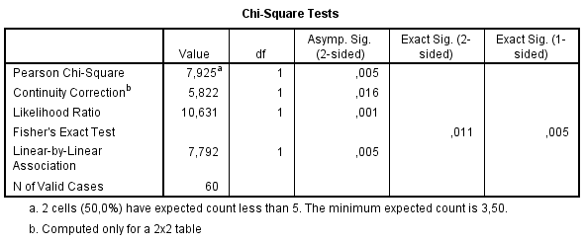

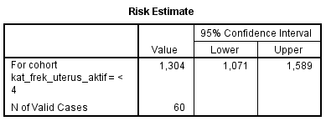

**kelompok1 * kat_lama_kons_uterus_aktif**

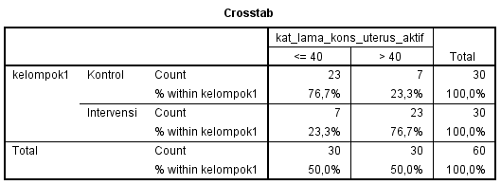

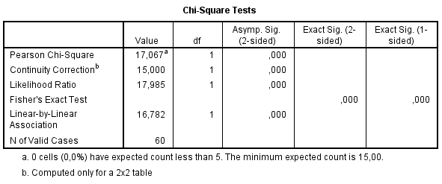

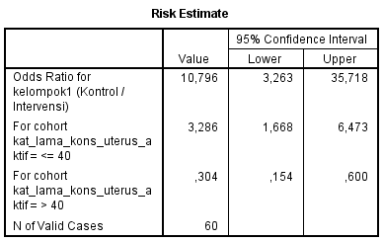

**Kelompok * kat_intensitas_kontr_uterus_aktif**

|  |  |  |  |  |  |
| --- | --- | --- | --- | --- | --- |
| **Crosstab** | | | | | |
|  | | | kat_intensitas_kontr_uterus_aktif | | Total |
| lemah | kuat |
| kelompok1 | Kontrol | Count | 18 | 12 | 30 |
| % within kelompok1 | 60,0% | 40,0% | 100,0% |
| Intervensi | Count | 7 | 23 | 30 |
| % within kelompok1 | 23,3% | 76,7% | 100,0% |
| Total | | Count | 25 | 35 | 60 |
| % within kelompok1 | 41,7% | 58,3% | 100,0% |

|  |  |  |  |  |  |
| --- | --- | --- | --- | --- | --- |
| **Chi-Square Tests** | | | | | |
|  | Value | df | Asymp. Sig. (2-sided) | Exact Sig. (2-sided) | Exact Sig. (1-sided) |
| Pearson Chi-Square | 8,297a | 1 | ,004 |  |  |
| Continuity Correctionb | 6,857 | 1 | ,009 |  |  |
| Likelihood Ratio | 8,526 | 1 | ,004 |  |  |
| Fisher's Exact Test |  |  |  | ,008 | ,004 |
| Linear-by-Linear Association | 8,159 | 1 | ,004 |  |  |
| N of Valid Cases | 60 |  |  |  |  |
| a. 0 cells (0,0%) have expected count less than 5. The minimum expected count is 12,50. | | | | | |
| b. Computed only for a 2x2 table | | | | | |

|  |  |  |  |
| --- | --- | --- | --- |
| **Risk Estimate** | | | |
|  | Value | 95% Confidence Interval | |
| Lower | Upper |
| Odds Ratio for kelompok1 (Kontrol / Intervensi) | 4,929 | 1,612 | 15,071 |
| For cohort kat_intensitas_kontr_uterus_aktif = lemah | 2,571 | 1,262 | 5,238 |
| For cohort kat_intensitas_kontr_uterus_aktif = kuat | ,522 | ,323 | ,844 |
| N of Valid Cases | 60 |  |  |

**kelompok1 * kat_pembukaan**



