Lampiran 17

Descriptive Statistic

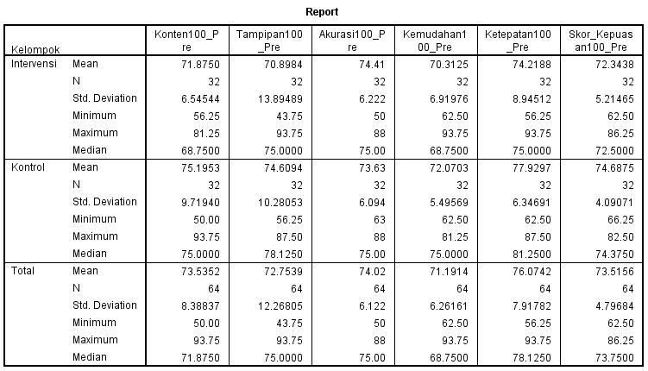

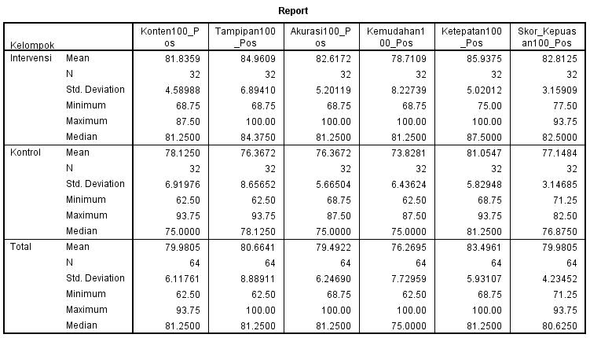

Uji Normalitas Data

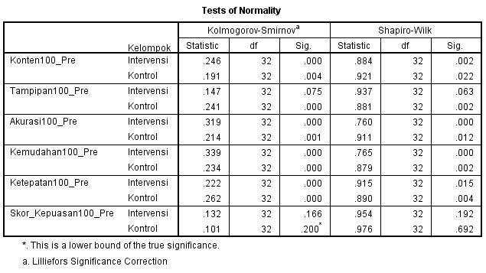

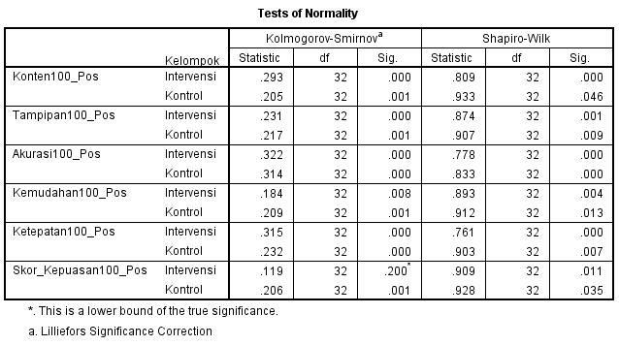

NPar Tests

Mann-Whitney Test

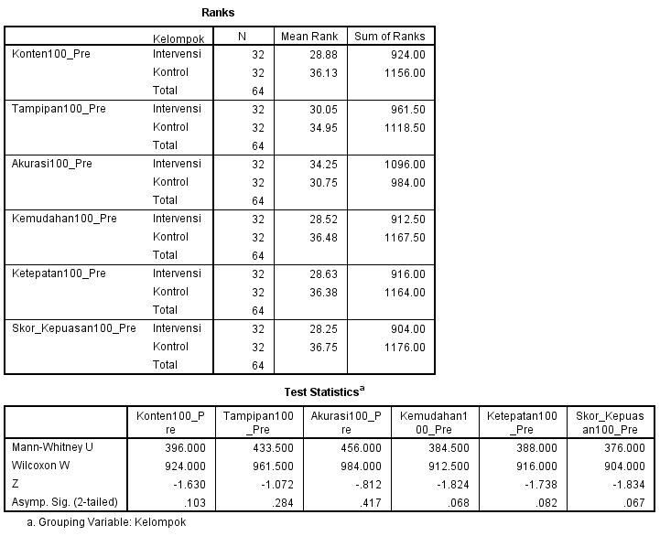

NPar Tests

Mann-Whitney Test
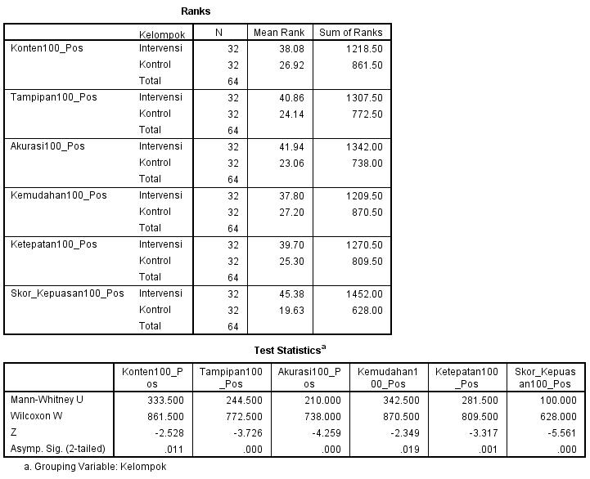
NPar Tests : Kelompok Intervensi

Wilcoxon Signed Ranks Test
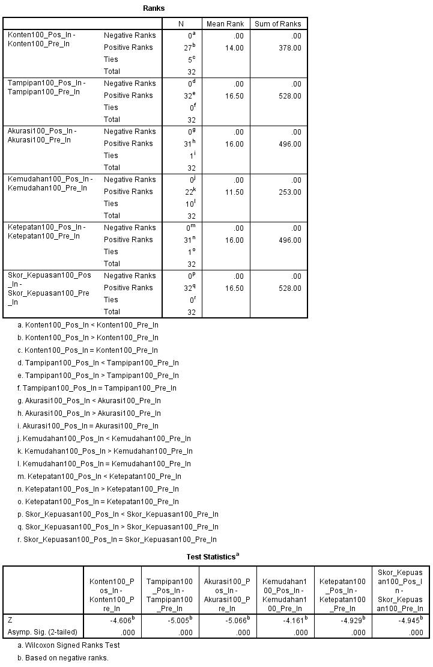

NPar Tests : Kelompok Kontrol

Wilcoxon Signed Ranks Test
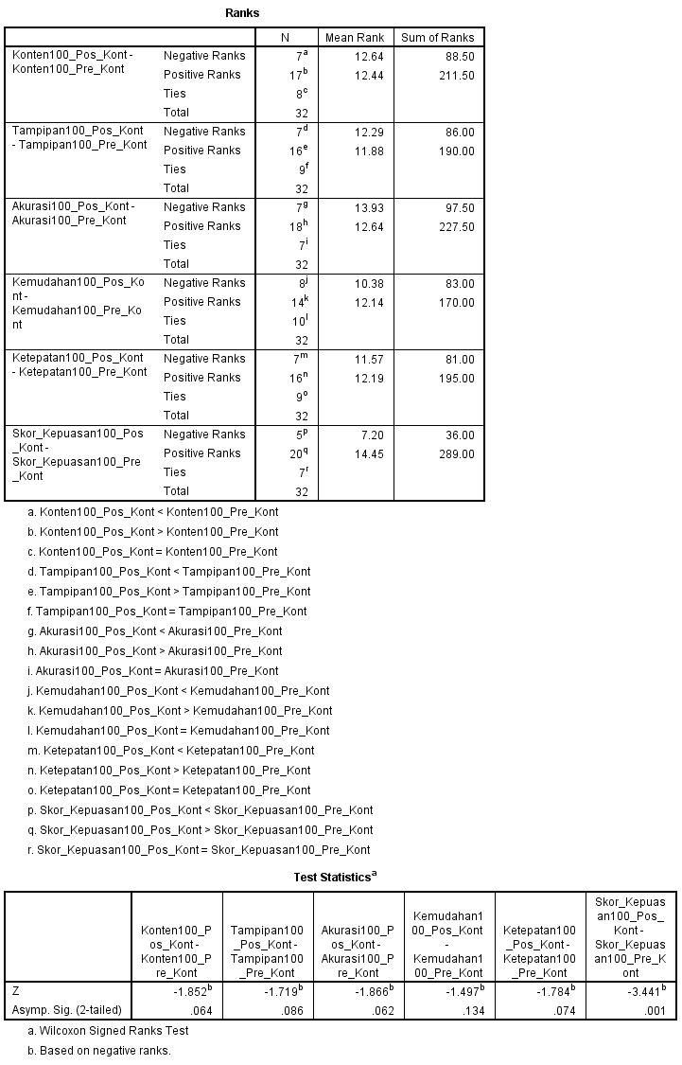

Kenaikan Skor Kepuasan

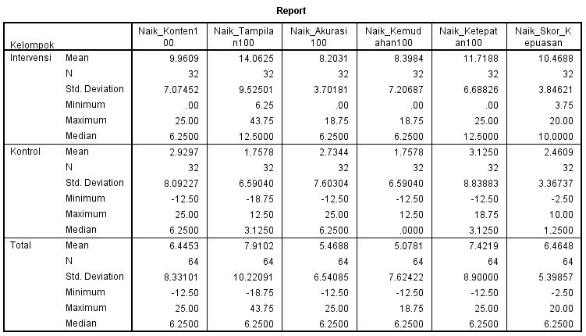

Persentase Kenaikan Skor Kepuasan

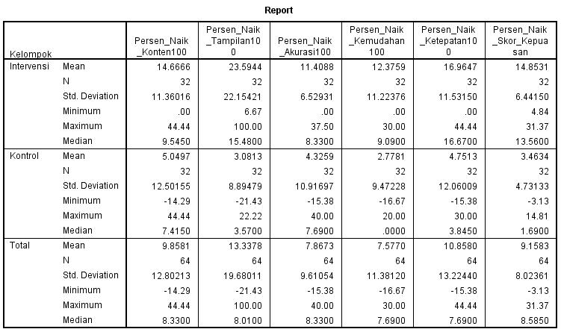

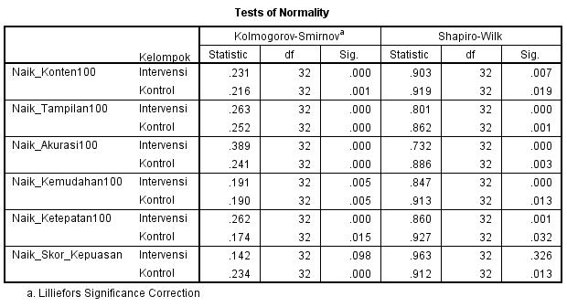

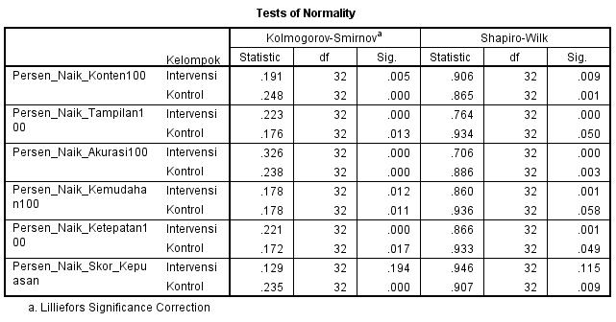

NPar Tests : Kenaikan Kepuasan

Mann-Whitney Test
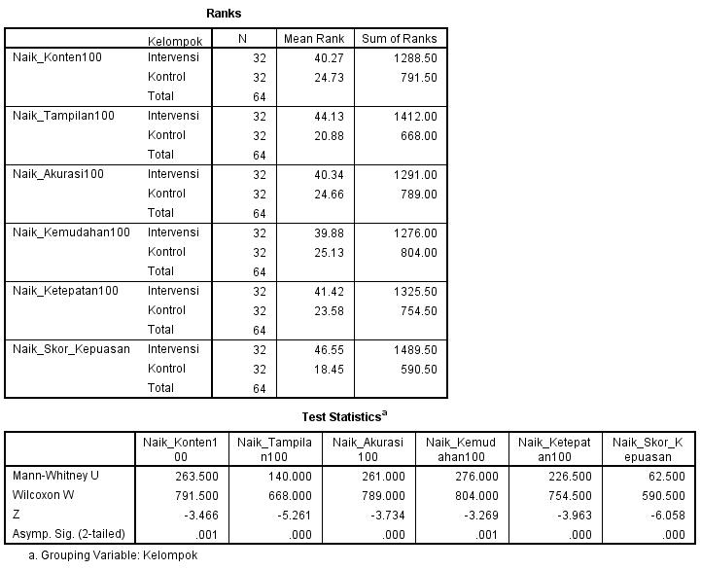
NPar Tests : Persen Kenaikan Kepuasan

Mann-Whitney Test

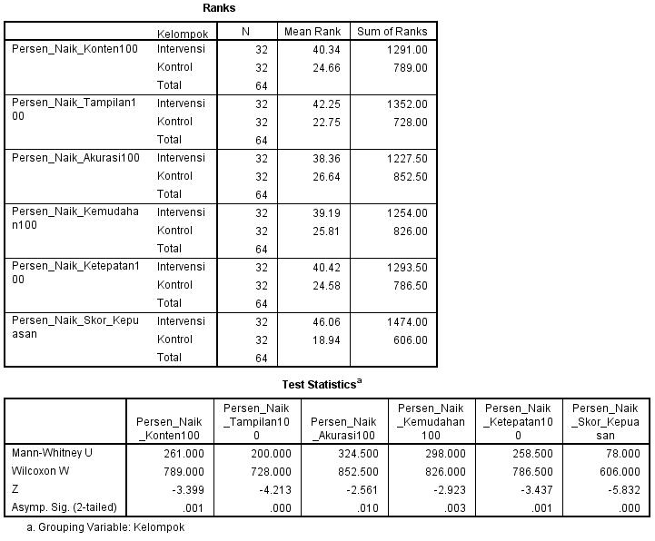

Crosstabs

Kelompok * Kategori Naik Kepuasan

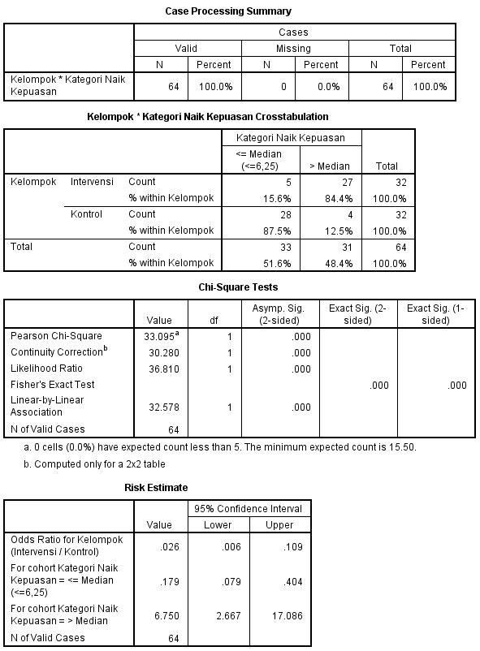
Crosstabs

Case Processing Summary
 | Cases
 | Valid |  | Missing |  | Total
 | N | Percent | N | Percent | N | Percent
Kelompok * Kepuasan | 64 | 100.0% | 0 | 0.0% | 64 | 100.0%
Kelompok * Kategori Kepuasan

Kelompok * Kepuasan Crosstabulation
 |  |  | Kepuasan |  | Total
 |  |  | Tidak Puas | Puas | Total
Kelompok | Kontrol | Count | 24 | 8 | 32
Kelompok | Kontrol | % within Kelompok | 75.0% | 25.0% | 100.0%
Kelompok | Perlakuan | Count | 5 | 27 | 32
Kelompok | Perlakuan | % within Kelompok | 15.6% | 84.4% | 100.0%
Total |  | Count | 29 | 35 | 64
 |  | % within Kelompok | 45.3% | 54.7% | 100.0%

Chi-Square Tests
 | Value | df | Asymp. Sig. (2-sided) | Exact Sig. (2-sided) | Exact Sig. (1-sided)
Pearson Chi-Square | 22.763ª | 1 | .000
Continuity Correction^{b} | 20.430 | 1 | .000
Likelihood Ratio | 24.433 | 1 | .000
Fisher's Exact Test |  |  |  | .000 | .000
Linear-by-Linear Association | 22.407 | 1 | .000
N of Valid Cases | 64
a. 0 cells (.0%) have expected count less than 5. The minimum expected count is 14.50.
b. Computed only for a 2x2 table

Risk Estimate
 | Value | 95% Confidence Interval
 | Value | Lower | Upper
Odds Ratio for Kelompok (Kontrol / Perlakuan) | 16.200 | 4.663 | 56.279
For cohort Kepuasan = Tidak Puas | 4.800 | 2.094 | 11.004
For cohort Kepuasan = Puas | .296 | .160 | .550
N of Valid Cases | 64

