COVER LETTER FOR SUBMISSION OF MANUSCRIPT

January 11, 2017

Dear editor,

I am pleased to submit an original research article and I am enclosing here with a manuscript entitled “THE EFFECT OF KEROKAN TO LIVER FUNCTION OF HEPATITIS-B PATIENTS” submitted to Journal of Medicine & Health for possible evaluation. This manuscript has not been published and is not under consideration for publication elsewhere. All the authors have directly approved the final version manuscript. We also no have conflicts of interest and hereby convey all copyright ownership exclusively to the journal.
Thank you for your consideration.
Sincerely,
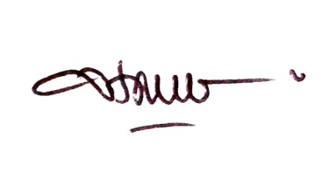

Hanna Sari Widya Kusuma
Aretha Medika Utama, Biomolecular and Biomedical Research Center
Bandung, West Java, Indonesia

