Lampiran 1. Daftar Perusahaan Makanan dan Minuman Periode 2015-2019
No | KODE | NAMA PERUSAHAAN
1 | AISA | PT. Tiga Pilar Sejahtera Food Tbk,
2 | ALTO | PT. Tri Banyan Tirta Tbk,
3 | CEKA | PT. Wilmar Cahaya Indonesia Tbk,
4 | DLTA | PT. Delta Djakarta Tbk.
5 | ICBP | PT. Indofood CBP Sukses Makmur Tbk,
6 | INDF | PT. Indofood Sukses Makmur Tbk,
7 | MLBI | PT. Multi Bintang Indonesia Tbk,
8 | MYOR | PT. Mayora Indah Tbk,
9 | PSDN | PT. Prasidha Aneka Niaga Tbk,
10 | ROTI | PT. Nippon Indosari Corporindo Tbk,
11 | SKBM | PT. Sekar Bumi Tbk,
12 | SKLT | PT. Sekar Laut Tbk,
13 | STTP | PT. Siantar Top Tbk,
14 | ULTJ | PT. Ultrajaya Milk Industry and Trading Company Tbk,

Lampiran 2. Hasil Statistik Deskriptif
Descriptive Statistics
 | N | Minimum | Maximum | Mean | Std. Deviation
X1_CONACC | 55 | -,113 | ,108 | -,00801 | ,045496
X2_LNTA | 55 | 26,656 | 32,201 | 29,05847 | 1,545094
X3_DER | 55 | ,100 | 1,870 | ,96890 | ,474656
X4_CR | 55 | ,580 | 4,844 | 1,97406 | 1,046344
X5_PL | 55 | -2,449 | 2,051 | ,18933 | ,715816
Y_QIR | 55 | -1,501 | 2,738 | ,97693 | ,827163
Valid N (listwise) | 55

Lampiran 3. Uji Asumsi Klasik
- Uji Normalitas
- Uji Normalitas dengan Grafik Normal P-P Plot

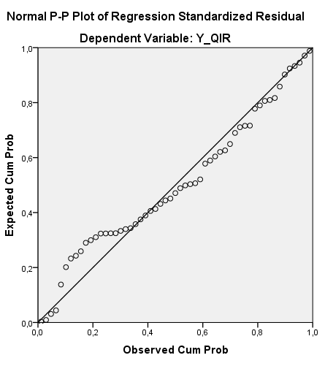

- Uji Normalitas dengan Kolmogorov-Smirnov Test
One-Sample Kolmogorov-Smirnov Test
 |  | Unstandardized Residual
N |  | 55
Normal Parameters^{a,b} | Mean | ,0000000
 | Std. Deviation | ,59434066
Most Extreme Differences | Absolute | ,117
 | Positive | ,078
 | Negative | -,117
Kolmogorov-Smirnov Z |  | ,867
Asymp. Sig. (2-tailed) |  | ,440
a. Test distribution is Normal.
b. Calculated from data.

B. Uji Multikolinearitas
Coefficientsª
Model |  | Collinearity Statistics
 |  | Tolerance | VIF
1 | X1_CONACC | ,990 | 1,010
 | X2_LNTA | ,859 | 1,164
 | X3_DER | ,411 | 2,432
 | X4_CR | ,444 | 2,252
 | X5_PL | ,969 | 1,033
a. Dependent Variable: Y_QIR

C. Uji Autokorelasi
Runs Test
 | Unstandardized Residual
Test Valueª | -,04573
Cases < Test Value | 27
Cases >= Test Value | 28
Total Cases | 55
Number of Runs | 24
Z | -1,223
Asymp. Sig. (2-tailed) | ,221
a. Median
D. Uji Heterokedastisitas
1) Uji Heterokedastisitas dengan Grafik Scatterplot
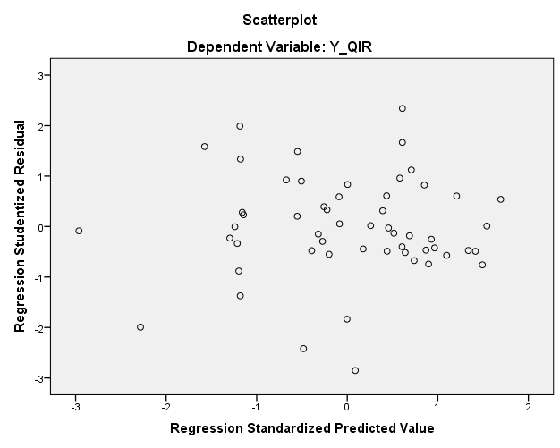
2) Uji Heterokedastisitas dengan Uji White
Model Summary^{b}
Model | R | R Square | Adjusted R Square | Std. Error of the Estimate
1 | ,479ª | ,230 | ,133 | ,55657
a. Predictors: (Constant), INTERAKSI, X3_2, X1_2, X5_2, X2_2, X4_2
b. Dependent Variable: RES2

Lampiran 4. Hasil Uji Hipotesis
- Uji Regresi Linear Berganda
Coefficientsª
Model |  | Unstandardized Coefficients |  | Standardized Coefficients | t | Sig.
 |  | B | Std. Error | Beta
1 | (Constant) | -2,062 | 1,860 |  | -1,109 | ,273
 | X1_CONACC | 8,345 | 1,876 | ,459 | 4,450 | ,000
 | X2_LNTA | ,126 | ,059 | ,236 | 2,131 | ,038
 | X3_DER | -,593 | ,279 | -,340 | -2,125 | ,039
 | X4_CR | -,014 | ,122 | -,017 | -,112 | ,912
 | X5_PL | ,199 | ,121 | ,172 | 1,648 | ,106
a. Dependent Variable: Y_QIR

- Uji Statistik Simultan (Uji F)
ANOVAª
Model |  | Sum of Squares | df | Mean Square | F | Sig.
1 | Regression | 17,872 | 5 | 3,574 | 9,182 | ,000^{b}
 | Residual | 19,075 | 49 | ,389
 | Total | 36,947 | 54
a. Dependent Variable: Y_QIR
b. Predictors: (Constant), X5_PL, X1_CONACC, X2_LNTA, X4_CR, X3_DER

- Koefisien Determinasi
Model Summary^{b}
Model | R | R Square | Adjusted R Square | Std. Error of the Estimate
1 | ,695ª | ,484 | ,431 | ,623928
a. Predictors: (Constant), X5_PL, X1_CONACC, X2_LNTA, X4_CR, X3_DER
b. Dependent Variable: Y_QIR

Lampiran 5. Tabulasi Data Penelitian
NO | TH | KODE | X1  CON  ACC | X2  LNTA | X3  DER | X4  CR | X5  PL | Y  QIR
1 | 2015 | AISA | -0,011 | 29,835 | 1,280 | 1,620 | -0,011 | 1,068
2 | 2015 | ALTO | -0,020 | 27,797 | 1,330 | 1,580 | 1,474 | 0,468
3 | 2015 | CEKA | 0,028 | 28,027 | 1,320 | 1,530 | 1,599 | 1,582
4 | 2015 | DLTA | -0,001 | 27,594 | 0,223 | 6,424 | -0,334 | 1,074
5 | 2015 | ICBP | 0,001 | 30,910 | 0,620 | 2,330 | 0,136 | 1,192
6 | 2015 | INDF | -0,015 | 32,151 | 1,130 | 1,710 | -0,291 | 1,136
7 | 2015 | MLBI | 0,108 | 28,373 | 1,740 | 0,580 | -0,375 | 1,850
8 | 2015 | MYOR | 0,054 | 30,060 | 1,180 | 2,370 | 2,051 | 1,869
9 | 2015 | PSDN | -0,006 | 27,154 | 0,910 | 1,210 | 0,541 | 0,533
10 | 2015 | ROTI | 0,064 | 28,627 | 1,280 | 2,050 | 0,434 | 2,053
11 | 2015 | SKBM | 0,014 | 27,362 | 1,220 | 1,120 | -0,554 | 1,556
12 | 2015 | SKLT | -0,017 | 26,656 | 1,481 | 1,930 | 0,190 | 1,478
13 | 2015 | STTP | -0,025 | 28,283 | 0,903 | 1,190 | 0,502 | 1,049
14 | 2015 | ULTJ | -0,002 | 28,895 | 0,265 | 3,746 | 0,848 | 1,280
15 | 2016 | AISA | -0,041 | 29,856 | 1,170 | 2,380 | 0,924 | 0,645
16 | 2016 | ALTO | 0,010 | 27,784 | 1,420 | 0,750 | 0,089 | -0,771
17 | 2016 | CEKA | -0,068 | 27,962 | 0,606 | 2,189 | 1,343 | 0,705
18 | 2016 | DLTA | 0,007 | 27,749 | 0,184 | 7,604 | 0,353 | 1,120
19 | 2016 | ICBP | 0,001 | 30,995 | 0,560 | 2,410 | 0,101 | 1,263
20 | 2016 | INDF | -0,002 | 32,040 | 0,870 | 1,510 | 0,420 | 1,362
21 | 2016 | MLBI | 0,031 | 28,453 | 1,770 | 0,680 | 0,976 | 1,271
22 | 2016 | MYOR | -0,096 | 30,190 | 1,060 | 2,250 | 0,111 | 0,475
23 | 2016 | PSDN | 0,058 | 27,206 | 1,330 | 1,060 | -0,140 | -0,666
24 | 2016 | ROTI | 0,007 | 28,702 | 1,020 | 2,960 | 0,034 | 1,482
25 | 2016 | SKBM | -0,077 | 27,633 | 1,720 | 1,110 | -0,438 | -1,501
26 | 2016 | SKLT | -0,062 | 27,066 | 0,919 | 1,300 | 0,029 | 0,079
27 | 2016 | STTP | -0,025 | 28,480 | 0,100 | 1,651 | -0,062 | 0,961
28 | 2016 | ULTJ | -0,019 | 29,075 | 0,215 | 4,844 | 0,357 | 1,098
29 | 2017 | AISA | 0,109 | 29,797 | -1,590 | 0,210 | -2,177 | -0,315
30 | 2017 | ALTO | 0,030 | 27,735 | 1,640 | 1,070 | 1,372 | -0,089
31 | 2017 | CEKA | 0,055 | 27,962 | 0,542 | 2,224 | -0,570 | 1,944
32 | 2017 | DLTA | 0,074 | 27,889 | 0,172 | 8,638 | 0,068 | 1,392
33 | 2017 | ICBP | 0,030 | 31,085 | 0,560 | 2,430 | -0,024 | 1,460
34 | 2017 | INDF | -0,009 | 32,108 | 0,880 | 1,520 | -0,023 | 1,265
35 | 2017 | MLBI | -0,087 | 28,551 | 1,360 | 0,830 | 0,346 | 1,007
36 | 2017 | MYOR | -0,060 | 30,333 | 1,030 | 2,390 | 0,174 | 0,782
37 | 2017 | PSDN | -0,113 | 27,261 | 1,310 | 1,160 | -1,877 | -0,773
38 | 2017 | ROTI | 0,025 | 29,148 | 0,620 | 2,260 | -0,516 | 2,738
39 | 2017 | SKBM | -0,096 | 28,115 | 0,590 | 1,640 | 0,148 | -3,812
40 | 2017 | SKLT | -0,061 | 27,179 | 1,069 | 1,300 | 0,113 | 0,094
41 | 2017 | STTP | 0,008 | 28,482 | 0,692 | 2,619 | 0,240 | 1,394
42 | 2017 | ULTJ | 0,042 | 29,277 | 0,233 | 4,192 | 0,003 | 1,507
43 | 2018 | AISA | 0,185 | 28,228 | -1,530 | 0,150 | -0,976 | -2,255
44 | 2018 | ALTO | -0,052 | 27,735 | 1,870 | 0,760 | -1,525 | 0,234
45 | 2018 | CEKA | 0,146 | 27,787 | 0,197 | 5,113 | -0,138 | 3,100
46 | 2018 | DLTA | 0,016 | 28,052 | 0,187 | 7,198 | 0,258 | 1,121
47 | 2018 | ICBP | -0,022 | 31,168 | 0,510 | 1,950 | 0,291 | 1,017
48 | 2018 | INDF | -0,019 | 32,201 | 0,930 | 1,070 | -0,036 | 1,196
49 | 2018 | MLBI | -0,009 | 28,692 | 1,470 | 0,780 | -0,074 | 1,153
50 | 2018 | MYOR | -0,141 | 30,498 | 1,060 | 2,650 | 0,460 | 0,193
51 | 2018 | PSDN | 0,063 | 27,271 | 1,870 | 1,030 | -2,449 | -0,382
52 | 2018 | ROTI | 0,008 | 29,111 | 0,500 | 3,571 | -0,061 | 2,327
53 | 2018 | SKBM | -0,060 | 28,203 | 0,700 | 1,380 | -0,384 | -3,497
54 | 2018 | SKLT | -0,050 | 27,340 | 1,203 | 1,200 | 0,391 | 0,459
55 | 2018 | STTP | -0,032 | 28,598 | 0,598 | 2,849 | 0,181 | 0,960
56 | 2018 | ULTJ | -0,049 | 29,346 | 0,164 | 4,398 | -0,013 | 0,820
57 | 2019 | AISA | -0,635 | 28,256 | -2,127 | 0,410 | -10,188 | 0,011
58 | 2019 | ALTO | 0,007 | 27,729 | 1,900 | 0,880 | -1,224 | -4,544
59 | 2019 | CEKA | 0,154 | 27,963 | 0,231 | 4,710 | 1,326 | 2,103
60 | 2019 | DLTA | -0,029 | 27,986 | 0,176 | 8,051 | -0,102 | 0,904
61 | 2019 | ICBP | 0,034 | 31,287 | 0,450 | 2,540 | 0,101 | 1,468
62 | 2019 | INDF | 0,046 | 32,197 | 0,770 | 1,270 | 0,190 | 2,261
63 | 2019 | MLBI | -0,041 | 28,695 | 1,530 | 0,730 | -0,015 | 1,107
64 | 2019 | MYOR | 0,001 | 30,577 | 0,920 | 3,430 | 0,135 | 1,222
65 | 2019 | PSDN | 0,084 | 27,361 | 3,340 | 0,760 | -0,447 | -2,226
66 | 2019 | ROTI | 0,018 | 29,175 | 0,500 | 1,693 | 0,860 | 2,029
67 | 2019 | SKBM | -0,067 | 28,230 | 0,760 | 1,330 | -0,940 | -84,515
68 | 2019 | SKLT | -0,016 | 27,396 | 1,079 | 1,300 | 0,407 | 1,232
69 | 2019 | STTP | -0,018 | 28,689 | 0,342 | 2,853 | 0,892 | 1,036
70 | 2019 | ULTJ | -0,013 | 29,519 | 0,169 | 4,444 | 0,475 | 1,059

