Appendix A
Data:
An informant, Mr.Mandacan Dorteus stated that:
- “We, local original who lived in the village could not make a farm in the forest for the forest is not ours. The forest was the right of the village head and his big family. We may only made a farm around the palm oil plantation where be found the spaces of palm oil.... So, we made only a farm around the palm oil area that we had.....”
- “The big local of Arfak do the cultivation in traditional. They aimed only to fulfill their food. They did not know or use the modern technology such as tractor or the modern agriculture machines. They used only a machete, a dibble, and an axe. Simply, Arfak local and other Papua found their inspiration from the forest. Forest as food provider made the local looks really suspend their life on and they keep hold their customary norm...” .
An informant (Mr. Ullo Luther) informed that:
- “.... we made a farm around palm oil area. The farm was not larger to plant. So, when we opened and handled an area, we did not need some helps from many people to clean, because we alone in our family might cleaned and made a farm.... not like the time before, our parents opened a farm in the forest and need many people (our big family) to clean.... Now each familes handled their own farm covered the palm oil for they got the simiar vast about two hectares”. The collective ritual was previously used for the area maintanance. Now, it had been changed by the personal activity with narrow meaning.

Other informant:
- “A forest is their mother who always supplies a food for their children”. On the other side, the Arfak local lost their area access which they used it traditionally. When, the area become valued commercially, the comers began to hande it, while the infrastructure was fail.

Appendix B
The research area
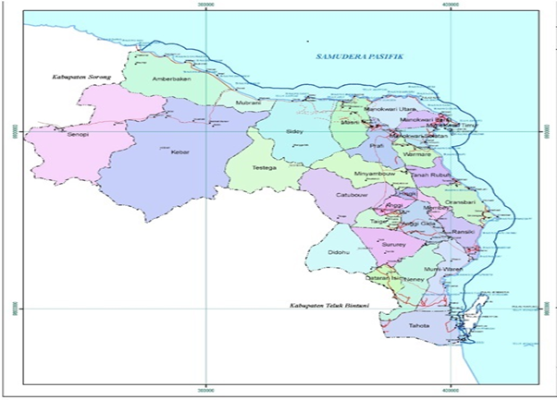

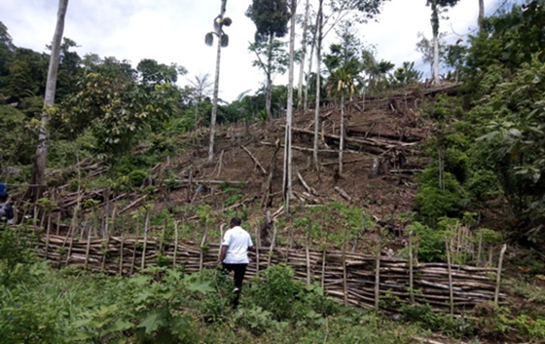
The picture of Arfak’s Shifting Cultivation

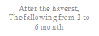
Arfak local farming cycle with the job family
Burned from
3 to 4 weeks



